TY_IT_69 Vaishnavi Ketan Tanna

**Experiment No.: 05**

## **Aim:** To study and Install Raspberry Pi

## **Objective:**To study Raspberry Pi

**Outcome:** Able to install Raspberry Pi and use it.

**Theory:**

The Raspberry Pi is a low cost, credit-card sized computer that plugs into a computer monitor or TV, and uses a standard keyboard and mouse. It is a capable little device that enables people of all ages to explore computing, and to learn how to program in languages like Scratch and Python. It’s capable of doing everything you’d expect a desktop computer to do, from browsing the internet and playing high-definition video, to making spreadsheets, word-processing, and playing games.

* The main difference between them is: Arduino is a microcontroller board, while Raspberry Pi is a microprocessor based mini computer (SBC).
* The Microcontroller on the Arduino board contains the CPU, RAM and ROM. All the additional hardware on the Arduino Board is for power supply, programming and IO Connectivity. Raspberry Pi SBC has all features of a computer with a processor, memory, storage, graphics driver, connectors on the board.
* Raspberry Pi needs an Operating System to run. Arduino doesn’t need any operating system. All you need is a binary of the compiled source code.
* Raspberry Pi comes with a fully functional operating system called Raspberry Pi OS (previously known as Raspbian OS). Although Pi can use different operating systems, Linux is preferred by Raspberry Pi Foundation. You can install Android, if you want. Arduino does not have any operating system. You just need a firmware instructing the Microcontroller what task to do.
* The clock speed of Arduino is 16 MHz while the clock speed of Raspberry Pi is around 1.2 GHz.

**Pin diagram and Architecture:**

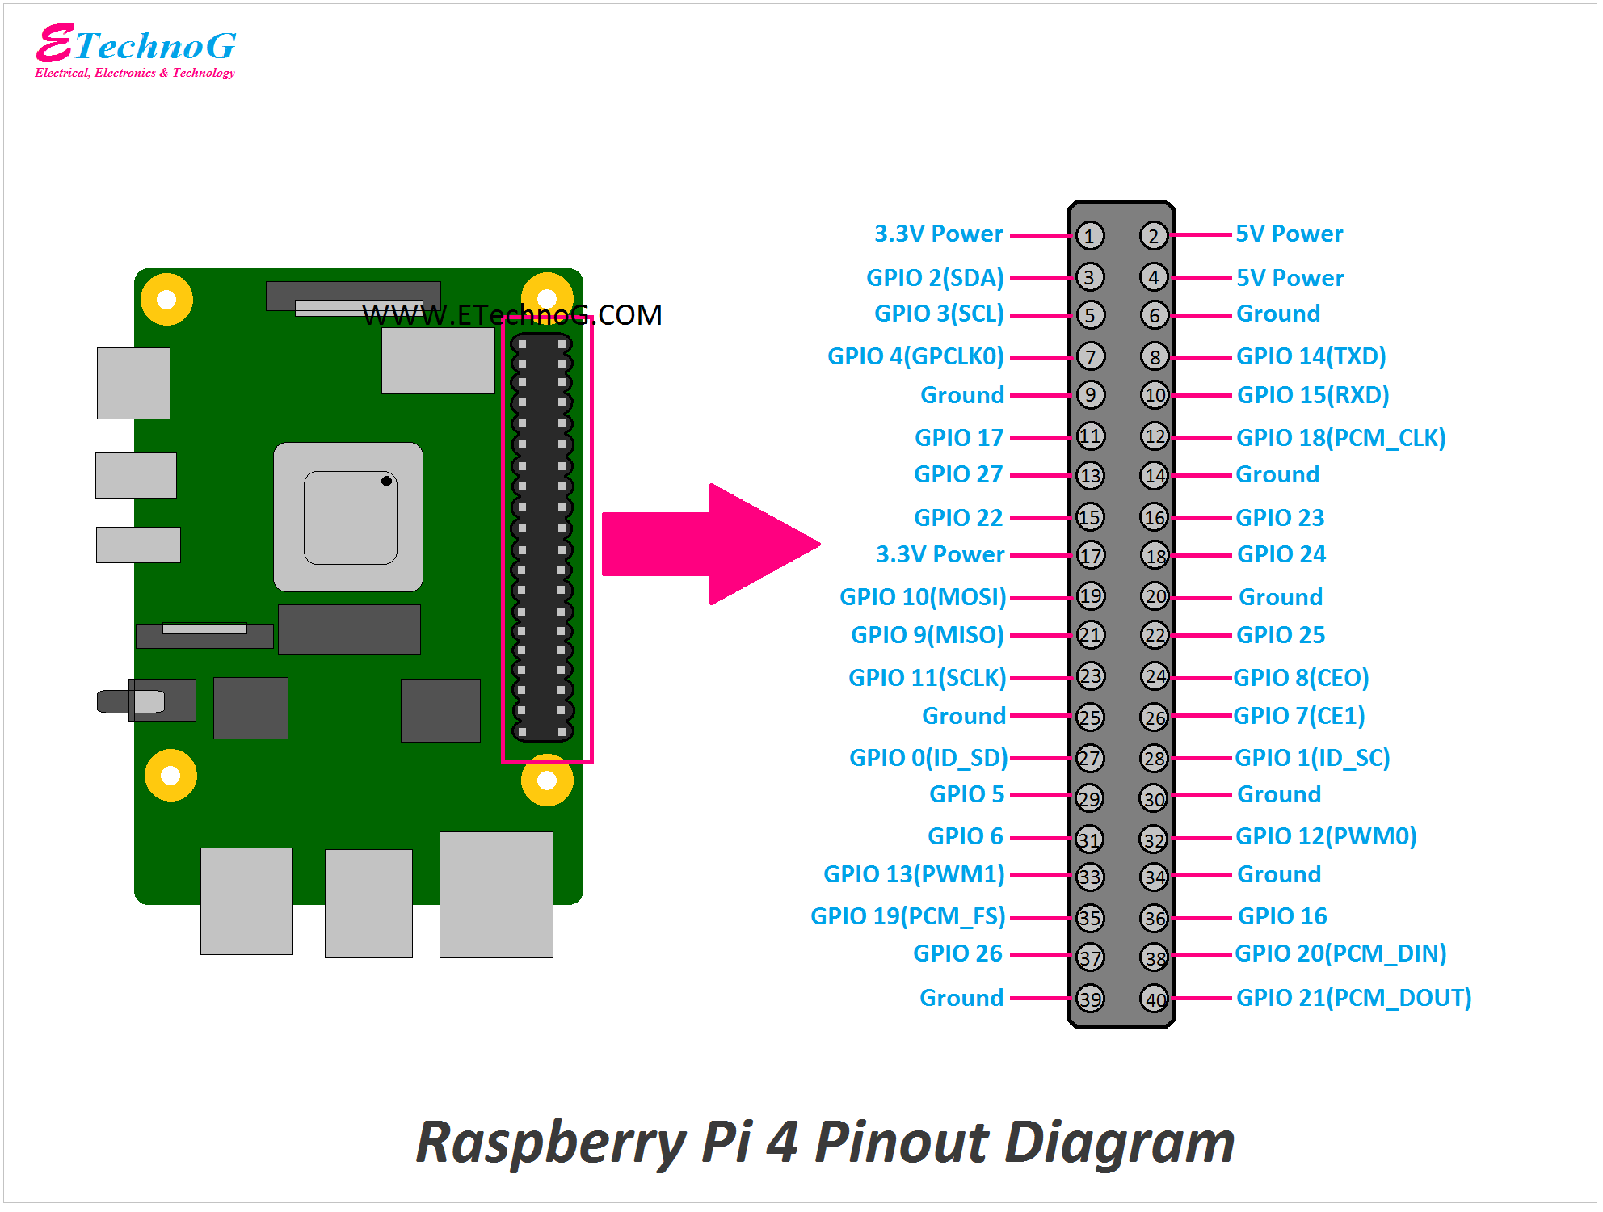

**Example:**

The applications of Raspberry Pi can be used as a game server as well. It is an excellent game server for Minecraft. If multiple Raspberry Pis are used, making one as a dedicated server, a great gaming experience can be achieved. Other multiplayer network games can be set up on the Raspberry Pi.

**OutPut:**

